LAPORAN PRAKTIKUM
PRAKTIKUM PEMROGRAMAN WEB
PERTEMUAN 6
SERVICE



Disusun Oleh
Nama : Muchammad Rifqi Chusaini S
NIM : 2300018289
Jadwal praktikum : Selasa 12.15

PROGRAM STUDI S-1 INFORMATIKA
FAKULTAS TEKNOLOGI INDUSTRI
UNIVERSITAS AHMAD DAHLAN
YOGYAKARTA
2025

DAFTAR ISI
DAFTAR ISI 2
BAB I PRETEST 3
1.1 Pretest 3
BAB II LANGKAH PRAKTIKUM 4
2.1 Buat akun baru di infinity free 4
2.2 Nanti disuruh buat domain dan password nya, lalu klik manage. 4
2.3 Buka Open in file manager 5
2.4 Upload File employee.php 5
2.5 Buat database lalu masuk ke query 6
2.6 Paste query yang diberikan asisten 7
2.7 Buka domain nya 7
BAB III POST TEST 8
3.1 Mahasiswa 8
3.2 Mata kuliah 9
3.3 Link Github 10

PRETEST

Pretest
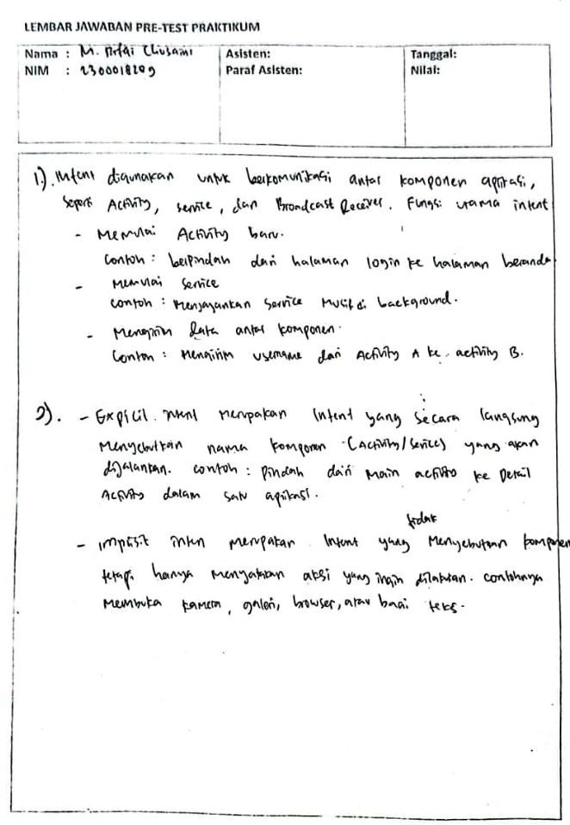

LANGKAH PRAKTIKUM

Buat akun baru di infinity free
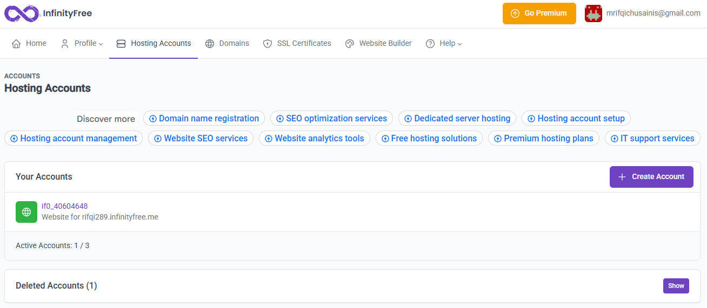

Nanti disuruh buat domain dan password nya, lalu klik manage.
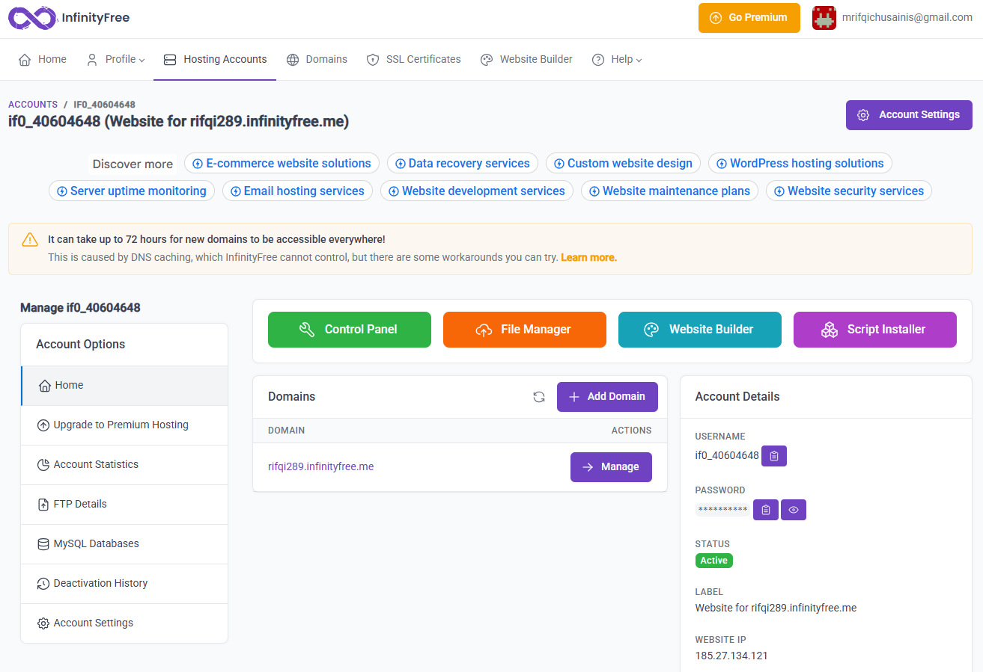

Buka Open in file manager
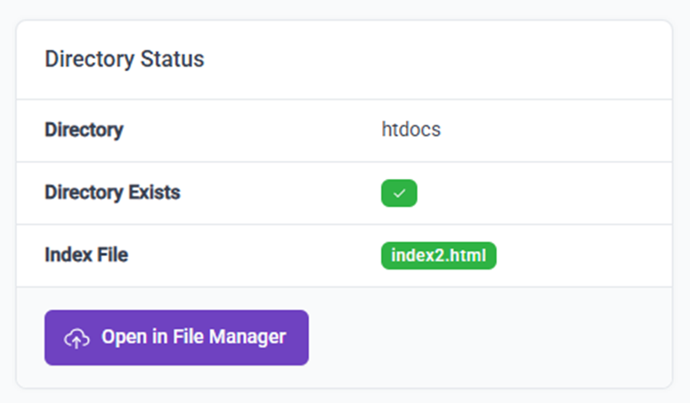

Upload File employee.php
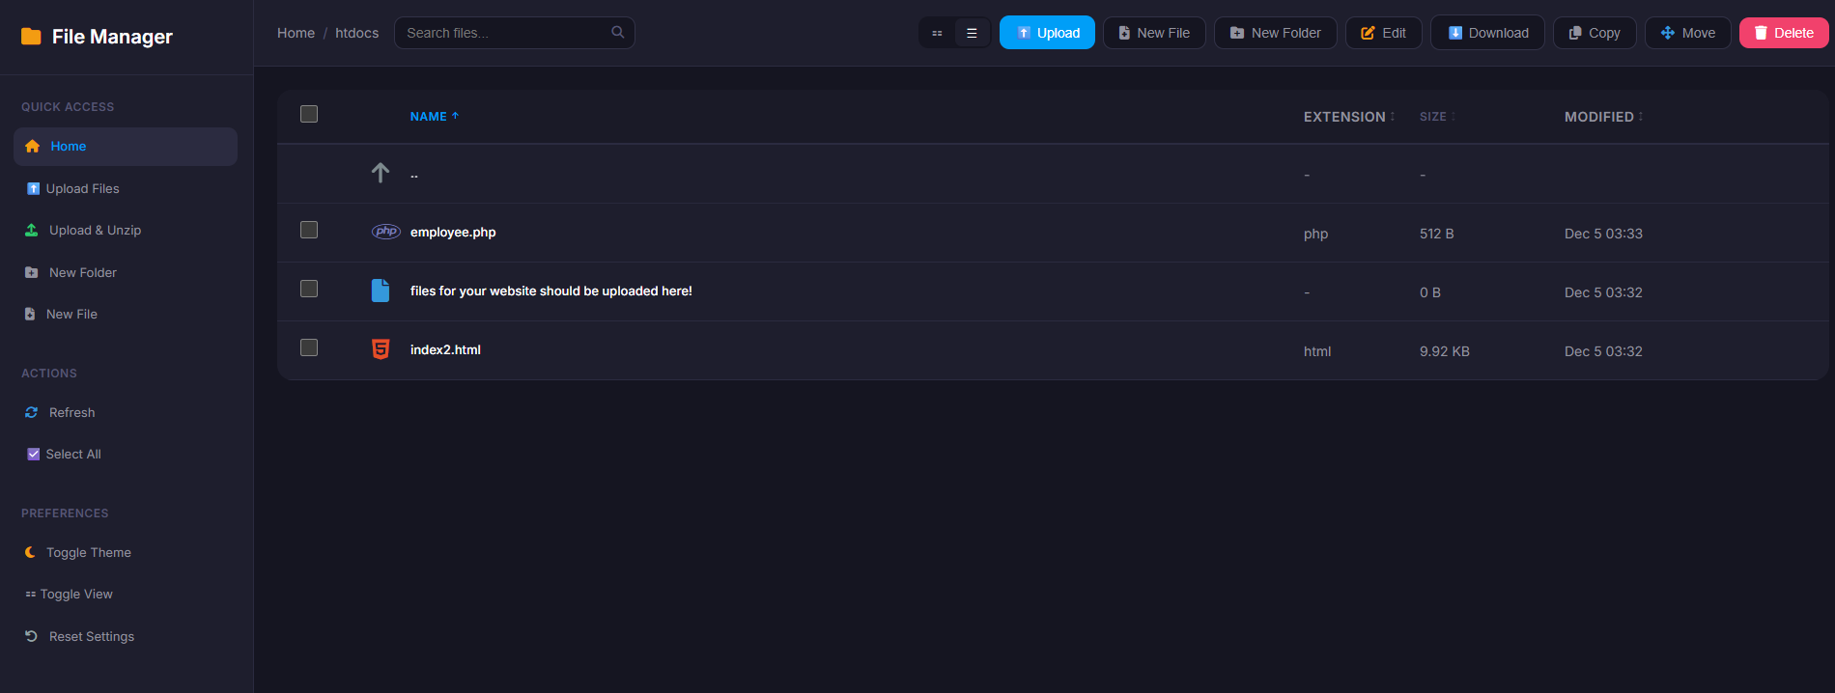

Buat database lalu masuk ke query
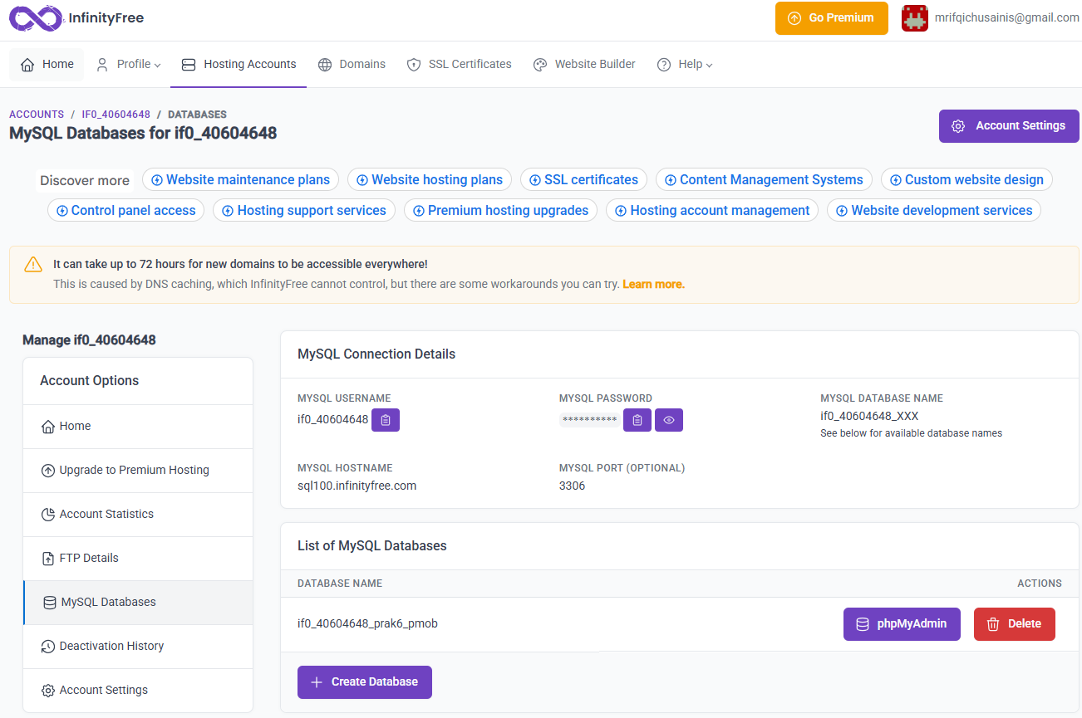

Paste query yang diberikan asisten
CREATE TABLE IF NOT EXISTS tbl_employee (
employee_id int(4) NOT NULL AUTO_INCREMENT,
employee_name varchar(60) NOT NULL,
jabatan varchar(30) NOT NULL,
tgl_kerja date NOT NULL,
gaji int(10) NOT NULL,
PRIMARY KEY (employee_id)
)
ENGINE=MyISAM DEFAULT CHARSET=latin1 AUTO_INCREMENT=1 ;
INSERT INTO tbl_employee (employee_id, employee_name,
jabatan,
tgl_kerja, gaji) VALUES
(1, 'Reza', 'VP', '2013-08-01', 60000),
(2, 'Adi', 'Executive', '2014-10-09', 20000),
(3, 'Isgi', 'Manager', '2013-08-20', 40000),
(4, 'Alfin', 'Executive', '2013-06-01', 25000),
(5, 'Onie', 'Trainee', '2014-10-01', 10000);
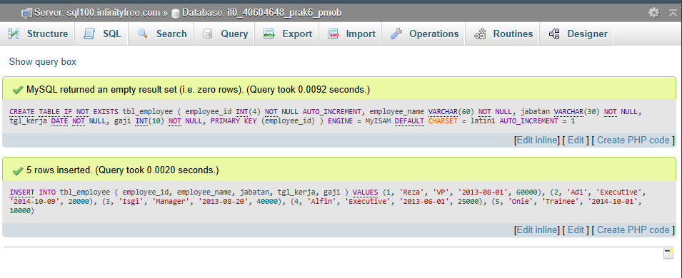

Buka domain nya
- https://rifqi289.infinityfree.me/employee.php

POST TEST

Mahasiswa
- Kode php
<?php

$host = "xxxx";
$user = "xxxx";
$pass = "xxxx";
$db = "if0_40604648_prak6_pmob";

$connection = mysqli_connect($host, $user, $pass, $db);

//query ke table Mahasiswa
$sql = "select * from Mahasiswa";
$result = mysqli_query($connection, $sql);

//pembuatan array
$emparray = array();
while($row = mysqli_fetch_assoc($result))
{
$emparray[] = $row;
}

//pembuatan json
echo json_encode($emparray);

//tutup koneksi
mysqli_close($connection);

?>

- Query sql
CREATE TABLE IF NOT EXISTS Mahasiswa (
NIM VARCHAR(12) NOT NULL,
nama VARCHAR(60) NOT NULL,
kelas VARCHAR(10) NOT NULL,
prodi VARCHAR(50) NOT NULL,
PRIMARY KEY (NIM)
)
ENGINE=MyISAM DEFAULT CHARSET=latin1;

INSERT INTO Mahasiswa (NIM, nama, kelas, prodi) VALUES
('23110001', 'Rifqi', 'TI-1A', 'Teknik Informatika'),
('23110002', 'Lutfi', 'TI-1A', 'Teknik Informatika'),
('23110003', 'Aulia', 'TI-1B', 'Sistem Informasi'),
('23110004', 'Dimas', 'TI-1B', 'Sistem Informasi'),
('23110005', 'Sarah', 'TI-1C', 'Teknik Komputer');

- Link
  - https://rifqi289.infinityfree.me/mahasiswa.php

Mata kuliah
- Kode php
<?php

$host = "xxxx";
$user = "xxxx";
$pass = "xxxx";
$db = "if0_40604648_prak6_pmob";

$connection = mysqli_connect($host, $user, $pass, $db);

//query ke table Mata_Kuliah
$sql = "select * from Mata_Kuliah";
$result = mysqli_query($connection, $sql);

//pembuatan array
$emparray = array();
while($row = mysqli_fetch_assoc($result))
{
$emparray[] = $row;
}

//pembuatan json
echo json_encode($emparray);

//tutup koneksi
mysqli_close($connection);

?>

- Query sql
CREATE TABLE IF NOT EXISTS Mata_Kuliah (
kode VARCHAR(10) NOT NULL,
nama_mk VARCHAR(60) NOT NULL,
sks INT(2) NOT NULL,
dosen VARCHAR(60) NOT NULL,
PRIMARY KEY (kode)
)
ENGINE=MyISAM DEFAULT CHARSET=latin1;

INSERT INTO Mata_Kuliah (kode, nama_mk, sks, dosen) VALUES
('MK101', 'Algoritma dan Pemrograman', 3, 'Dr. Andi Prasetyo'),
('MK102', 'Basis Data', 3, 'Ibu Siti Rahmawati'),
('MK103', 'Jaringan Komputer', 3, 'Pak Budi Santoso'),
('MK104', 'Sistem Operasi', 3, 'Pak Roni Kurniawan'),
('MK105', 'Pemrograman Web', 3, 'Ibu Dewi Lestari');

- Link
  - https://rifqi289.infinityfree.me/mataKuliah.php

Link Github
https://github.com/rifqichusaini/Praktikum-Pemrograman-Mobile/tree/main/P5-Recyclerview/Post

